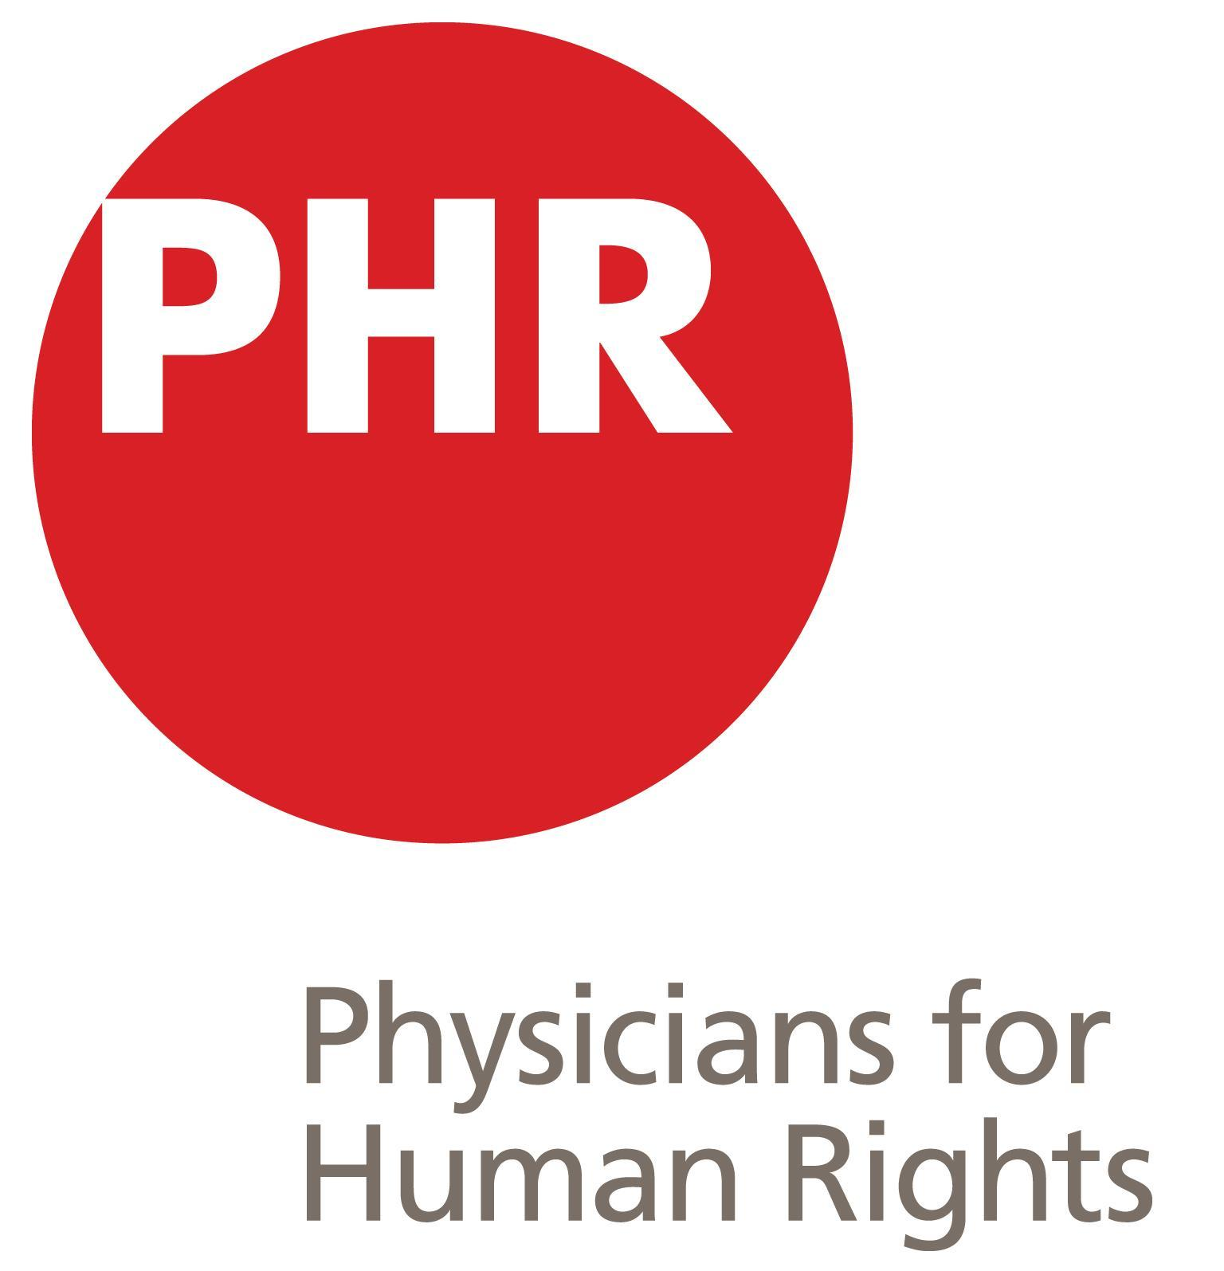
2022 PHR National Student Conference Application

Please submit this application to phr.sab@gmail.com by Wednesday, April 22, 2022.

School Name: _________________________

- Your contact information – name, email, and phone number for each member of the proposal committee.

- Explanation of your interest in hosting the conference. Please comment on your institution’s willingness to host an in-person conference in the light of COVID-19. Be sure to have discussed this with your administration prior to applying.

- The current status of your institution’s PHR student chapter – please include activities organized over the past year, the number of members, and any additional information that might be important to the selection committee.

- Resources available to you for the conference, including physical space, audio-visual support, media or public-relations assistance, institutional support/administrative approval, plans for funding, and an estimate of the number of students who can help organize the conference.

- A brief description of your event-planning experience.

- A tentative theme for the conference, as well as ideas for unique discussion formats. Please keep in mind that all conference topics should speak directly to PHR's core missions, which can be reviewed at phr.org. These ideas need not be highly detailed or fully formed, as the PHR staff and the PHR Student Advisory Board will provide ample guidance and consultation.

- Questions, if any, that you have for the selection committee. Please note that previous conference hosts typically donate $300-500 of the conference’s funds raised to the SAB to further their advocacy, asylum, and future conference efforts. We are happy to answer any questions and work with your committee regarding this donation.

